Example of Option 1

* Shows only successful execution of code for option 1 (and implicitly 3)
* Instructions: “shows the steps indicating that you have executed the program successfully”, which satisfy that execution of program occurs.

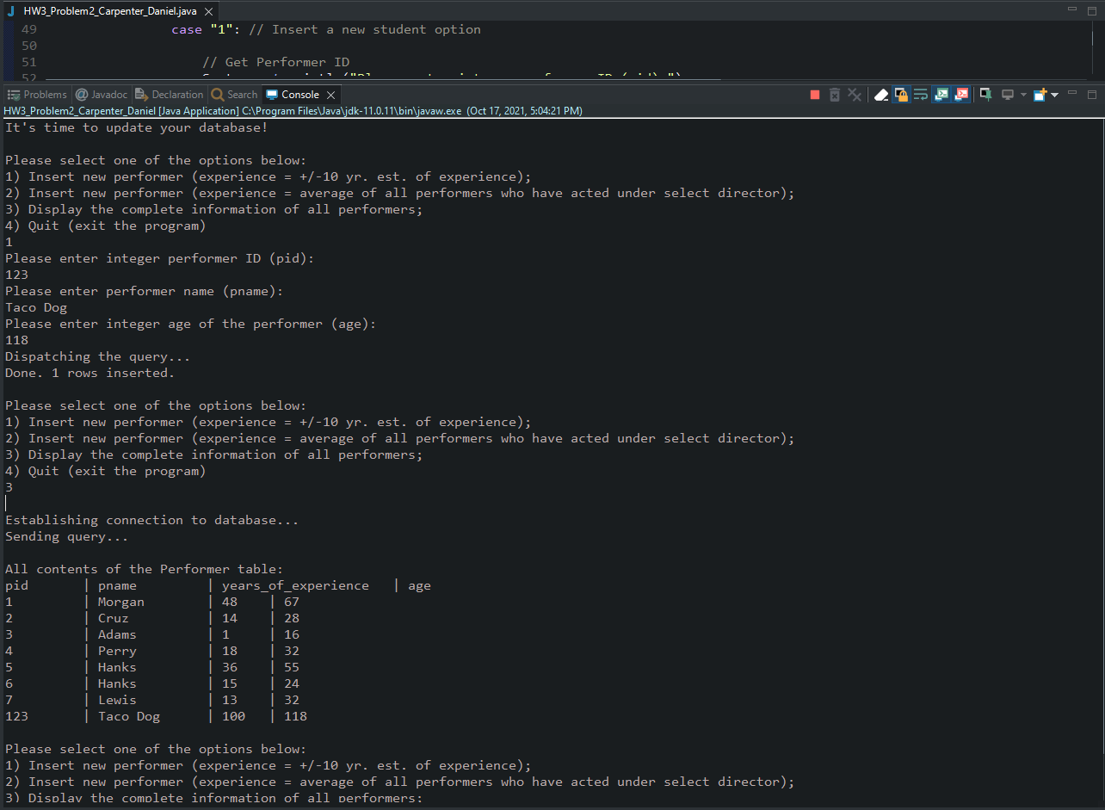

Example of Option 2

* Shows only successful execution of code for option 2 (and implicitly 3)
* Instructions: “shows the steps indicating that you have executed the program successfully”, which satisfy that execution of program occurs.

